1. Vagrantfile

Vagrant.configure("2") do |config|

config.vm.network "public_network", bridge: "Intel"

onfig.vm.box = "ubuntu/trusty64"

end

vagrant up:

vm1: port number 2200

vm2: port number 2222

vm3: port number 2201

1. Create three directories such as vm1, vm2, and vm3 and save the above Vagrantfile in each directory.

VM1: ssh -p 2200 [vagrant@127.0.0.1](mailto:vagrant@127.0.0.1)

VM2: ssh -p 2222 vagrant@127.0.0.1

VM3: ssh -p 2201 vagrant@127.0.0.1

Check their IP address through ifconfig

VM1: 192.168.1.73

VM2: 192.168.1.72

VM3: 192.168.1.74

Change their host name:

VM1: sudo hostname active1

VM2: sudo hostname active2

VM3: sudo hostname passive1

Add IP address with hostnames into file /etc/hosts.

Sudo vim /etc/hosts

127.0.0.1 localhost

192.168.1.73 active1

192.168.1.72 active2

192.168.1.74 passive1

Modify bind_ip in /etc/mongod.conf in all three virtual machines:

Sudo vim /etc/mongod.conf

net:

port: 27017

bind_ip: 192.168.1.73

net:

port: 27018

bind_ip: 192.168.1.72

net:

port: 27019

bind_ip: 192.168.1.74

1. On three cmd window:

Create directory in each of them:

sudo mkdir -p /db/active1/data

sudo mkdir -p /db/active2/data

sudo mkdir -p /db/passive1/data

vagrant@active1:~$ sudo mongod --port 27017 -dbpath /db/active1/data --replSet myReplicaSet --smallfiles --oplogSize 128 --bind_ip 192.168.1.73

vagrant@active2:~$ sudo mongod --port 27018 -dbpath /db/active2/data --replSet myReplicaSet --smallfiles --oplogSize 128 --bind_ip 192.168.1.72

vagrant@passive1:~$ sudo mongod --port 27019 -dbpath /db/passive1/data --replSet myReplicaSet --smallfiles --oplogSize 128 --bind_ip 192.168.1.74

1. On the fourth cmd window:

mongo 192.168.1.73:27017

rs.initiate()

rs.status()

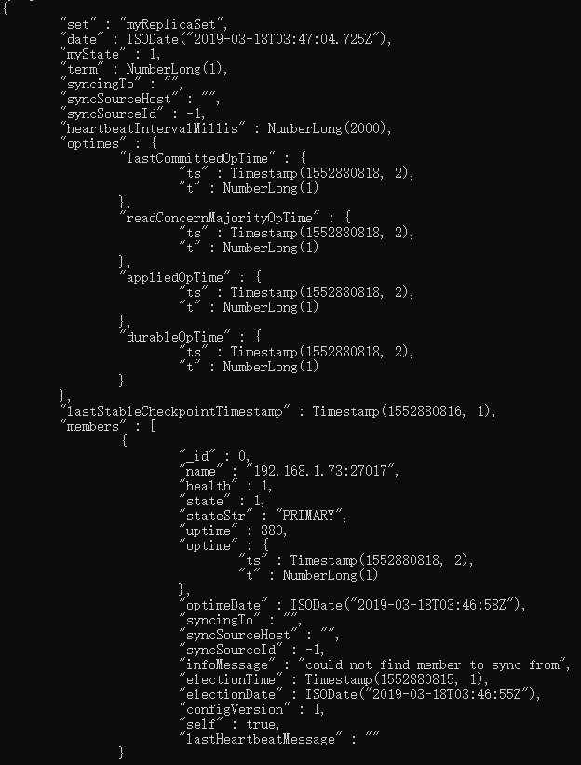

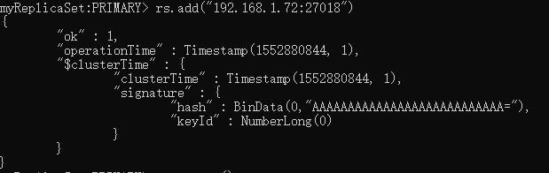

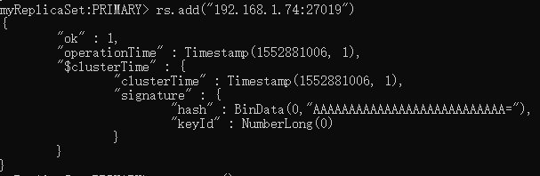

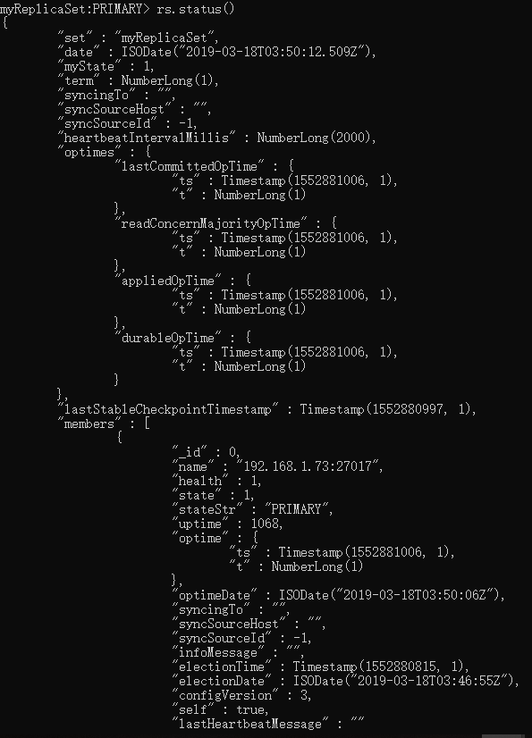

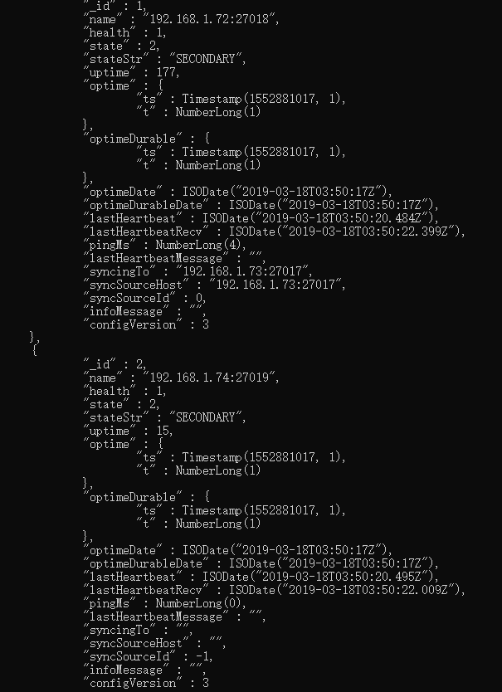

1. Use example to check if replica set has been implemented correctly.

